- Features

Meet KPU: Karl Petersen

Petersen published his fifth book that was used for one of his courses this spring semester
April 22, 2023 Emma Bolzner
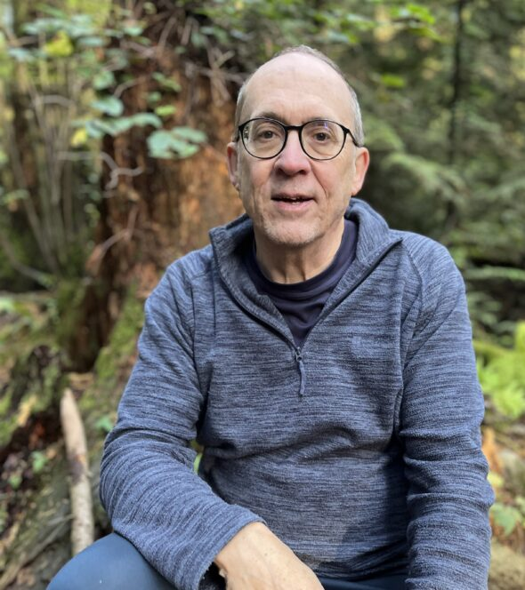Karl Petersen is an English instructor at KPU who recently published the novel, Stars Beyond the Veil, which he used as course material for one of his classes. (Submitted)
Listen to Post
Karl Petersen has been an English instructor at Kwantlen Polytechnic University for over 20 years. He recently published his novel Stars Beyond the Veil and used it as course material for one of his advanced English language studies classes this spring semester. The book is a sequel to his 2017 epic fantasy novel The Kingdom of What Is, and is his fifth published book.
While Petersen enjoys being an author, he also likes working and being part of the KPU community.

When did you join the KPU community, and why?
I came to KPU in 2002 to teach in the English Language Studies program. I taught in other English language programs at other institutions before, but KPU had a unique focus that I really liked and seemed to fit me really well. Students here are very serious about advancing their English skills because they have a long range purpose, they want to graduate and get jobs, so that really drew me in.
I felt that KPU really wanted me here and that they saw things in me that they liked. I was contributing to the community more than many other schools I have taught at. The smaller class size helps and makes it feel more personal. The reason I’ve stayed for so long is I really feel respected as a professional in my field. I am trusted to achieve the goals and benchmarks of the program without someone looking over my shoulder. I have not had that everywhere and here we are 21 years later.
For me, teaching is always personal. It is always face-to-face, especially in a program where students are learning English language skills. Working post-pandemic is a big improvement because now we have options of online courses. Blended courses are what I excel at and prefer the most. Online does not suit me very well, especially when I am teaching, listening, and speaking in classes.

What is your favourite story of your time at KPU?
There are several, but one that stands out in my mind is recently, I published a book, Stars Beyond the Veil, that I now use as a course reading text. The novel is about a 15-year-old girl and her two friends who have to go on the run from the law and pass through a portal into another world, which is even worse than the world they left. At first, I thought I would be too self-promoting to teach from my own book and I didn’t know how students would receive it.
However, teaching is storytelling. By using my novel as a reading text, I am doing that. I believe learning can sink in better through stories and that is what I have found by using my own novel as a text for teaching English reading skills. I like that I have a chance to tell my story face to face. A lot of times we tell stories in the form of novels and films, but we seldom meet the storytellers. It has been pretty well received and students get engaged more. When former students come back to me years later and tell me how much they liked my class and how they have been reading my other books, then I think I am doing something right.

What is something that you’d like to say to people new to the community?
Be patient. Learning is a lifelong process. Don’t think too far ahead to what you are going to be doing after school or you lose the moment. My dad used to say to me when I was a student that ‘Your job right now is to be a student. Don’t worry about what’s coming later, whether you’re going to get a job or not.’
While you’re learning, enjoy the community and make friends. This is the best part of learning too, and maybe the best part, because in your relationships, studying together, playing together and sharing your stories, is where you find the longest lasting learning experiences.

What are you working on right now?
I’m working on another book. It’s called Quarter Rest. It is a collection of musings and poems and nothing like the novels I have written in the past. They’re mostly about what happens during those brief pauses in our day to day work and activities when we reflect on what we experienced and express the eternal significance of those moments and what lies ahead. I called it Quarter Rest with the thought that approximately a quarter of our time, outside of work, eat and sleep, some say, is spent at leisure. It’s like the quarter rest in a bar of music, though it’s a solid pause with meaning because the rest both reflects back and anticipates ahead. I don’t know if I’ll ever try using it for my class, maybe portions of it, but it could be an entry into blog writing perhaps.

What is something you would like people to know about you?
I am crazy about my family, the natural world, environment, spirituality, theology, social justice, movies, and the T.V. series NOVA on PBS. There is so much cool stuff on NOVA that I otherwise would not learn. I’m an eclectic. I know something about a lot of things, but not a lot of things about something.
A summary of his books to date and where to purchase them can be accessed on his website.

